# **Implementation Summary**

Oliver, Jacob, Pietro, Nick

For User Story #1, “Interact with search form”, Jacob and Oliver created a functioning GUI with a drop down menu to select a filter. Pietro created methods that will allow us to see queries and search results.

For User Story #2, “Input CSVFile”, Jacob and Oliver researched csv file input within Databases. Jacob found that csv excel files can be imported with a small modification so our database can be populated with data.

For the “Display Table” user story, Pietro created a method to display the information fetched from the database in the GUI.

Nick extended GUI drop down menu functionality for several filters, allowing users to select their preferred filters. Their choice is recorded as a String. The following user stories were implemented in the GUI:

* “State Filter”
* “Visa Filter”
* “Industry Filter”
* “Year Filter”
* “Payment Filter”

In addition, Jacob created methods with Pietro that accessed database information to be displayed in the GUI. This was for the user story “Create Table”

**Instructions**

Our program currently contains three parts:

1. Iteration 1.0: Program that displays our full database in a GUI (this requires creating the database in phpMyAdmin in order to run)

These three parts need to be run separately. The instructions are as follows:

1. Iteration 1.1: Program that displays a GUI with filters for the database in drop down menus
2. Iteration 1.2: Program that reads in a demo data file in .csv format and prints the data (experiences) in the table. The Junit tests are part of this program.

Iteration 1.0:

Start By Importing an Excel File into a MySQL Database……

1. Select the “new” option from the phpMyAdmin tabs along the left side of the phpMyAdmin Database website.

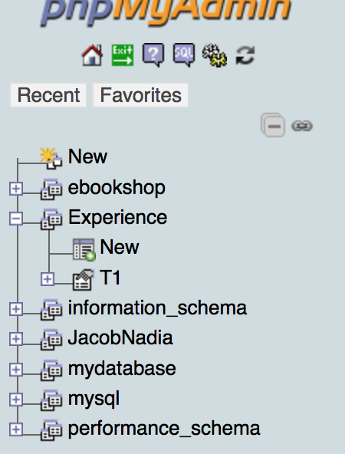

1. Enter the name of your database and then click create

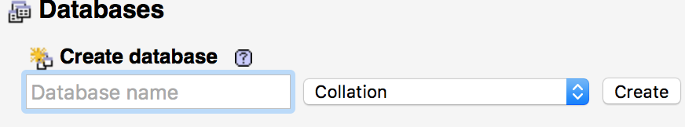

1. Select the import tab within your newly created database. 

Click the choose file button and then select the excel file you want. For these instructions, the right excel can be found by going to the data tagged with iteration 1 > DataBaseSearchTest > summer experience survey 2016 for oliver.csv 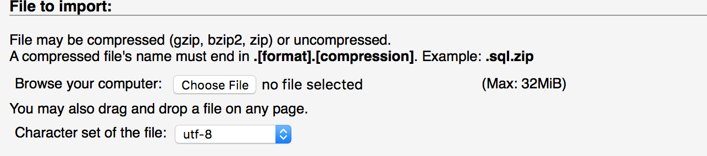

1. Make sure to check the box “The first line of the file contains the table column name.”

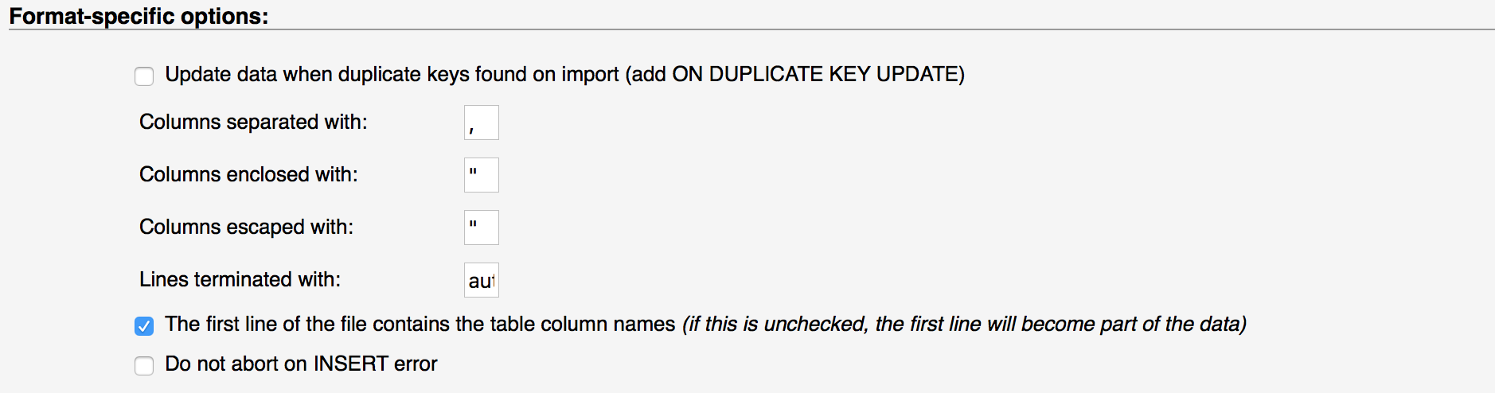

1. Select Go> Your table will be imported into your database.
2. Download the MySQL connector jar file in order to connect your java code in Eclipse to your newly created database (<https://dev.mysql.com/downloads/connector/j/5.0.html)>.
3. In Eclipse, right click on your project folder in eclipse select “build path” > “add external archives” > select the file “mysql-connector-java-5.1.44-bin.jar” > your eclipse program will now be able to have the ability to connect to the MySQL database.

Iteration 1.0(cont)

1. After completing the above instructions select the tag “iteation1.0”
2. Open the java project DataBaseSearchTest as well as the .java files that are within it.
3. Run the project, see the database table created in the GUI

Iteration 1.1: GUI with filters

1. Select the tag “iteation1.1”
2. Select the folder NickGUITest/src
3. Open NickExperience and NicksGUI in a new java project within eclipse (names will soon be changed)
4. Run the java project to see the GUI that will soon be storing our database table (not there yet)

Iteration 1.2: Reading in a demo data file and running tests

1. Select the tag “iteration1.2”
2. Open Java Project folder Iteration1
3. Select SummerExperienceProgram-Iteration1
4. Select SW Final
5. Download files in src
6. Open test folder from SW Final
7. Select DBTest.java
8. Add DBTest.java to the DataBaseSearchTest java project in eclipse
9. Run JUnit Test Case